Fire Council Meeting 3/6/2019 – CAD Update

- Response Times – This seems to be a heated issue and I would like to clear up some of the misconceptions about how we got where we are. Zuercher CAD was a mystery to much of the 911 staff before I got hired in April of 2018. There were many plans that were put in place regarding how dispatch was going to operate in the ZT environment based on what they had heard the CAD system could or could not do. One of the plans that were put in place (who decided this I still don’t know) was to dispatch using a default or generic incident code that would merely open the ProQA interface. The dispatcher was to then work through the protocol and assign units after the protocol matched to one of the many incident codes that the council had worked on previous to going live. This has created response times that are longer (3:23 last month) than they should be at the CFS creation-to-Units Assignment level. John Hinkle and I identified that these times were too long and have had a plan in place to remedy it for a while. We were only waiting to see if the new way could get to the time frame that was acceptable before changing back to the pre-alerts of old. The times seem to have bottomed out around 3 minutes and we are aware this is not acceptable. Starting April 1st , we will be opening ProQA with the base incident code as stated by the RP in the initial call questions.

What does this mean to you:
- You will no longer get the proqa notes in the initial page.
- All updates after the protocol is completed will be announced over the radio.
- Units using Field Ops or Mobile CAD will be able to see the updates live.
- Updates to the fire runcards may be necessary due to units assigned. John and I have tested many of the fire runcards from multiple agencies to verify that additional units from initial code to actual will not create unneeded pages and they hold up. Here is how it will work:

RP calls in stating that they see smoke coming from a building at whatever address.
Dispatcher opens CFS, enters address, and enters STRUCTURE FIRE – 69 as the incident code. Units are then assigned(paged) based on the runcard of the agency created for the event type STRUCTURE FIRE-69. In this example, 2 engines and 1 ambulance. The dispatcher then finishes the ProQA protocol and it updates the incident code to STRUCTURE FIRE – HIGH LIFE. The runcard that the agency has created for that event type would then be layered onto the initial runcard with the exclusion of the 2 engines and 1 ambulance.

Example runcard: STRUCTURE FIRE -69 BFD

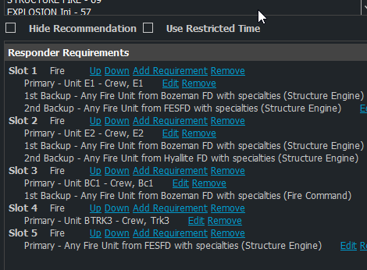
Page sent to E1, E2, BC1, Trk3, and an engine from Fort Ellis.

This turns into STRUCTURE FIRE-HIGH LIFE
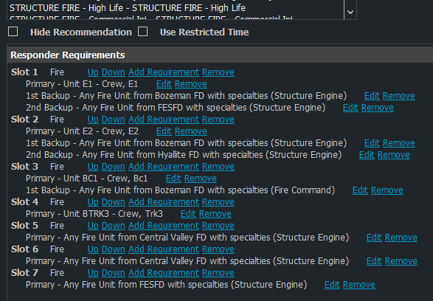
Second page is sent to Central Valley Fire for 2 engines.

- Escalation\Alarm Packages – Worksheets have been created for each agency. I would like to implement these changes by April 1st. The original unit packages will remain, we just need to define who is coming by agency. We can setup workshops if needed.

- ProQA Fire 7.0 – This is a big one. Will need a concentrated effort by all agencies to create a committee and get these whipped out. There are many changes and we shouldn’t be afraid of creating a couple more incident codes to contain them. There are handouts but working on these in a PC are recommended. All updates/work should be completed on this by April 1st.

